 | Depto.: Inglés  Miss Silvia | Evaluación unidad cero  4tos medios | 

Student’s name: |  | Level: |  | Date:

Puntaje real: 31 PUNTOS | Puntaje obtenido: | NOTA:
Objetivo: Evaluar los contenidos generales enseñados durante el último mes.
Instrucciones: Leer cuidadosamente las instrucciones y responder en los espacios dados para esto, ya sea de manera digital o en lápiz PASTA.
SUBIR EVALUACIÓN AL TÉRMINO DE LA CLASE. SI SUBES LA EVALUACIÓN DURANTE LA HORA DE CLASE EL PORCENTAJE DE EXIGENCIA ES 60%. SI NO CUMPLES CON LOS PLAZOS ESTABLECIDOS SERÁS EVALUADA CON 70% DE EXIGENCIA.

I) Transform the following sentences using reported speech. (3 puntos c/u)
- Dua Lipa: I love to watch anime
_________________________________________________________
- Pablo Alborán and Joy: We have a great time together this afternoon.
_________________________________________________________
- Ed Sheeran: I enjoyed to sing my songs!
_________________________________________________________
- Pink: I like to cut my hair.
_________________________________________________________

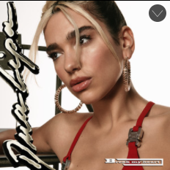
II) Choose the correct alternative according reported speech (2 puntos c/u)
- Direct Speech: “You question my love like it’s not enough”

- She said that he questioned her loved liked it wasn´t enough”
- He said she question my love like it was not enough
- She said he questioned my loved like it´s not enough

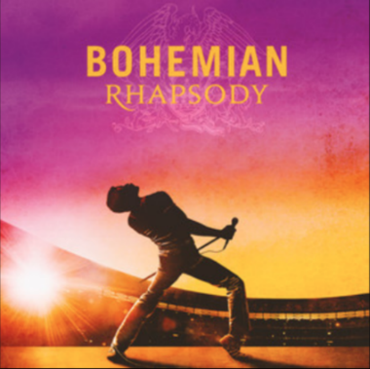

- Direct Speech: “I have to be sure when I walk out that door”

  - He said I had to be sure when I walked out that door
  - He said he have to be sure when I walked out that door
  - He said he had to be sure when he walked out that door

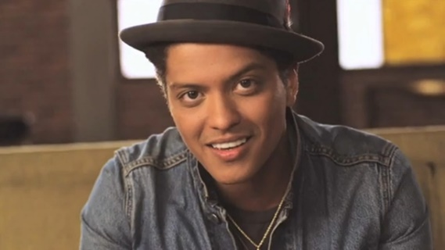

- Directed speech: She's so beautiful and I tell her everyday

  - He said she is so beautiful and I tell her everyday
  - He said she was so beautiful and he told her everyday
  - He said she’s so beautiful and he telled her everyday
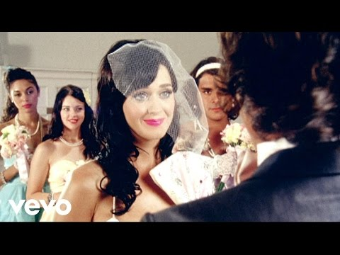

- Directed speech: You're wrong when it's right

  - She said he was wrong when it was right
  - She said she is wrong when it’s right
  - She says he was wrong when it was right

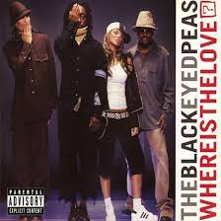

- Directed Speech: Why are there pieces of love that don't belong?

  - They said why are there pieces of loved that don’t belonged
  - They said why were there pieces of love that did not belong
  - They said why was there pieces of love that didn´t belonged
III) Reading comprehension: Read the text and answer the questions about it with your own words. (3 puntos c/u)
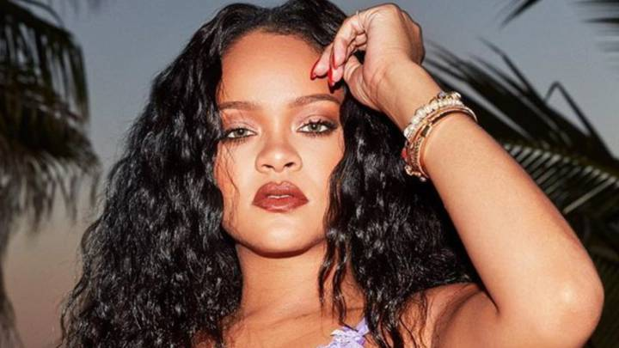
Rihanna, as it turns out, kind of does need an introduction. There are the bits we know: The 31-year-old Barbadian entertainer and mogul has nine Grammy Awards, 10 signature fragrances, thriving beauty and lingerie businesses, and a new ready-to-wear line for the fashion behemoth LVMH. She has broken a handful of Guinness World Records, she was the first black woman to be the face of Dior, she has acted with everyone from Cara Delevingne to Cate Blanchett, and former president Barack Obama has called her “a powerful force in the fight to give people opportunity, dignity, and hope.”
And yet, there’s another side to the blunt-smoking purveyor of genre-shattering pop that few people ever get to see. “I’m so shy,” she says, “I don’t even want you to know I’m shy.” In the three years since her chart-topping eighth album, Anti, Rihanna has kept a relatively low profile—at least for one of the most famous women in the world. But as she tells her friend and Ocean’s 8 castmate Sarah Paulson, it’s time to get back to—ugh, don’t hate us—work, work, work, work, work, work.

- How does Rihanna describe herself?
________________________________________________________________________________________________________________________________________________________________________________________________________________________________________________________________________________________________

- Why did Rihanna break the Guinness World Records?
________________________________________________________________________________________________________________________________________________________________________________________________________________________________________________________________________________________________
- How did Barack Obama describe to Rihanna?
________________________________________________________________________________________________________________________________________________________________________________________________________________________________________________________________________________________________
